

Instructions

The following social story can be used when orientating a new child to your program. It is a word document so it can be easily adapted to suit your specific program and child. The pages below are used as a guide to what could go into the social story, but you are able to add anything else that is relevant.
Once you have inserted images of your program/instructors/team and added the relevant text, the story can be emailed to the child’s family. Please instruct the family to add their child’s photo to the first page. Also, ask the family to read the story with their child prior to attending their first session. Remember to take out any instructions that are displayed on the pages prior to sending them out to families.

My name is (insert child’s first name)

Insert child’s photo if applicable.

I am going to (insert name of place/program).

Insert photo of venue.
This can include any applicable areas of the venue,
e.g., the outside or inside of the building,
relevant rooms/areas or fields.

I will be going to (name of program/place) on (day/s) at (time if applicable).

(Please enter the relevant day and time below. The day and time can be adjusted, and the hands of the clock can be moved).

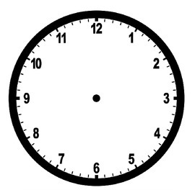

Saturday

10:00
My (insert relevant title e.g., instructor/team leaders) is/are:

(Insert photos of instructor/team leaders)

Insert photo here
Insert photo here

(Insert name) (Insert name)

At (name of program/place) I will be (insert activity e.g., playing soccer or having dance lessons etc.)


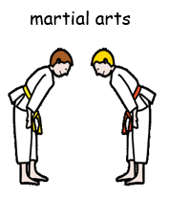
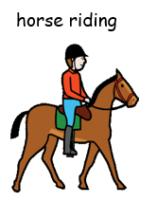

(Insert a relevant visual that depicts the activity. A variety of images can be found on the visual aids resource in this toolkit. Alternatively, you may have your own photos or find images on the internet)

(Please insert any other relevant information that will assist the child to orientate in the program,
e.g. equipment needed, uniforms etc. Include photos or images that relate to these.)
Insert photo here



Great

